|  |  |  |
| --- | --- | --- |
| **Sr. No.** | **Contents** | **Page No.** |
| **1** | **Annexure I– Micro Project Proposal** | **1-2** |
| 1.Aims/Benefits of the Micro-Project | 1 |
| 2. Course Outcome Addressed | 1 |
| 3.Proposed Methodology | 1 |
| 4. Action Plan | 2 |
| 5. Resources Required | 2 |
| 6. Name of Team Members with Roll No.’s | 2 |
| **2** | **Annexure II – Micro Project Report** | **3-8** |
| 1.Rationale | 3 |
| 2.Aims/Benefits of the Micro-Project | 3 |
| 3.Course Outcome Achieved | 4 |
| 4. Literature Review | 5 |
| 5.Actual Methodology Followed | 6 |
| 5.1 Flow chart | 6 |
| 5.2 Source code | 7-9 |
| 6.Actual  Resources Used | 10 |
| 7.Outputs of Micro-Projects | 10 |
| 8. Skill developed / Learning out of this Micro-Project | 11 |
| 9. Applications of this Micro-Project | 11 |

**Annexure I**

**Micro Project Proposal**

**“Develop A Program in ‘C’ that creates tree to store given data set using linkedlist representation. Locate and Display a specific data from the data set”**

**1. Aims/Benefits of the Micro-Project:**

1. Understanding the how binary tree works & how we store data into it.

2. To find working mechanism of linked list by using data structure concepts.

3. To understand the flow of program interpretion, functions and execution of the ‘C’ program.

**2. Course Outcome Addressed:**

1) CO1 – Perform basic operations of array.

2) CO2 – Apply different searching and sorting techniques.

3) CO3 – Implement basic operations on stack and queue using array representation.

4) CO4 – Implement basic operations on Linked list.

5) CO5 – Implement program to create and traverse tree to solve problems.

**3. Proposed Methodology:**

Storing the Data using linked list representation that takes or creates a binary within the program using some logic implementation.

This Program retrieve or insert the required data by the help of array and linked list.

This C Program is developing a tree to store given data set using linked list representation. And show the specific data from the given data set and locate its position or value.

**4.Action Plan**:

|  |  |  |  |  |
| --- | --- | --- | --- | --- |
| **Sr.**  **No.** | **Details of Activity** | **Planned**  **Start date** | **Planned**  **Finish date** | **Name of Responsible Team Members** |
| 1 | Search the topic | 29/08/2022  4:00pm-5:00pm | 05/09/2022  4:00pm-5:00pm | Sujit Sudhakar Sukane |
| 2 | Search the information | 12/09/2022  4:00pm-5:00pm | 19/09/2022  4:00pm-5:00pm | Harsh Moreshwar Kale |
| 3 | Algorithm developing | 26/09/2022  4:00pm-5:00pm | 03/10/2022  4:00pm-5:00pm | Sujit Sudhakar Sukane |
| 4 | Flowchart developing | 10/10/2022  4:00pm-5:00pm | 15/10/2022  4:00pm-5:00pm | Akshay Dashrath Gitte |
| 5 | Function making | 31/10/2022  4:00pm-5:00pm | 21/11/2022  4:00pm-5:00pm | Harsh Moreshwar Kale |
| 6 | Coding developing | 14/11/2022  4:00pm-5:00pm | 21/11/2022  4:00pm-5:00pm | Harsh Moreshwar Kale |
| 7 | Debugging | 28/11/2022  4:00pm-5:00pm | 05/12/2022  4:00pm-5:00pm | Akshay Dashrath Gitte |
| 8 | Finalizing Project with its report | 12/12/2022  4:00pm-5:00pm | 19/12/2022  4:00pm-5:00pm | Sujit Sudhakar Sukane |

**5. Resources Required:**

|  |  |  |  |  |
| --- | --- | --- | --- | --- |
| **Sr.**  **No.** | **Name of resource / material** | **Specification** | **Quantity** | **Remarks** |
| 1 | Computer | WINDOWS 11, 8GB RAM, 160GB HDD | 1 |  |
| 2 | Operating System | WINDOWS 11 | 1 |  |
| 3 | Compiler | Turbo C/GCC/VS code | 1 |  |
| 4 | Browser | Chrome | 1 |  |

**Names of Team Members with Roll No.’s:**

|  |  |  |  |
| --- | --- | --- | --- |
| **Sr.**  **No.** | **Enrollment No.** | **Name of Team Member** | **Roll No.** |
| 1 | 2110950049 | Akshay Dashrath Gitte | 01 |
| 2 | 2110950051 | Harsh Moreshwar Kale | 03 |
| 3 | 2110950159 | Sujit Sudhakar Sukane | 60 |
| 4 |  |  |  |
| 5 |  |  |  |

**Mr. Chavan A. Y.**

**Name and Signature of the Teacher**

**Annexure – II**

**Micro-Project Report**

**“Develop A Program in ‘C’ that creates tree to store given data set using linkedlist representation. Locate and Display a specific data from the data set”**

1. **Rationale:**

In this program, we need to create the binary tree by inserting nodes and displaying nodes in inorder fashion. A typical binary tree can be represented as follows:

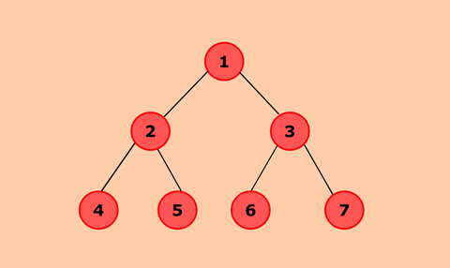

This three is get stored inside the linked list using linked list representation. Although we want to display or retrieve data from the linked list.

**2. Aims/Benefits of the Micro-Project:**

1. Understanding the behavior of linked list.

2. Learn to make binary tree using linked list.

3. To Understand how the actual program works like storing a data in binary tree form.

4. Learn to design programs based on terminal and implementing logic on them.

**3. Course Outcomes Achieved:**

1) CO1 – Perform basic operations of array.

2) CO2 – Apply different searching and sorting techniques.

3) CO3 – Implement basic operations on stack and queue using array representation.

4) CO4 – Implement basic operations on Linked list.

5) CO5 – Implement program to create and traverse tree to solve problems.

**4. Literature Review:**

We used Data Structure & Algorithm to store the data in computer there are multiple ways to store data, We tell computer how to perform simple addition and substraction operation using stack.

How we can able to store data efficiently in computer that all can be done with data structure and algorithms.

* Binary tree -
* A binary tree is **a tree-type non-linear data structure with a maximum of two children for each parent**. Every node in a binary tree has a left and right reference along with the data element. The node at the top of the hierarchy of a tree is called the root node. Class is type or a category of things.
* It is similar to a structure with the difference that it can also have functions besides data items.
* A structure, we have seen, can have only data variables but a class can have data members as well as function members.

**Diagrammatic representation of binary tree:**

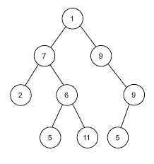

* Linked list –

A linked list is **a sequence of data structures, which are connected together via links**. Linked List is a sequence of links which contains items. Each link contains a connection to another link. Linked list is the second most-used data structure after array.

**Diagrammatic representation of Linked list:**

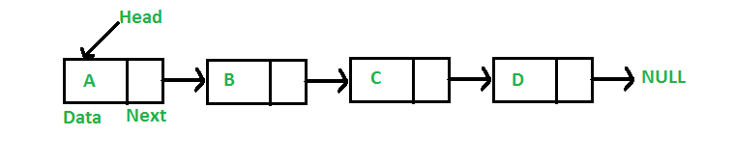

Let’s take look on example that clears linked list more precisely, Just like a garland is made with flowers, **a linked list is made up of nodes**. We call every flower on this particular garland to be a node. And each of the node points to the next node in this list as well as it has data (here it is type of flower).

* **Advantage of Data Structures in Computer Science:**
* It’s easy to store information in computer system.
* Retrieving data is becomes fast.
* Use of memory is get efficiently.
* We can perform addition, substraction, multiplication and division in computer by using stack method.
* Mostly used for maintaining servers.
* Their some sorting method which are bubble sort, selection sort those are useful to sort the given data efficiently.

**5 Actual Methodology Followed:**

**5.1 Flow Chart:**

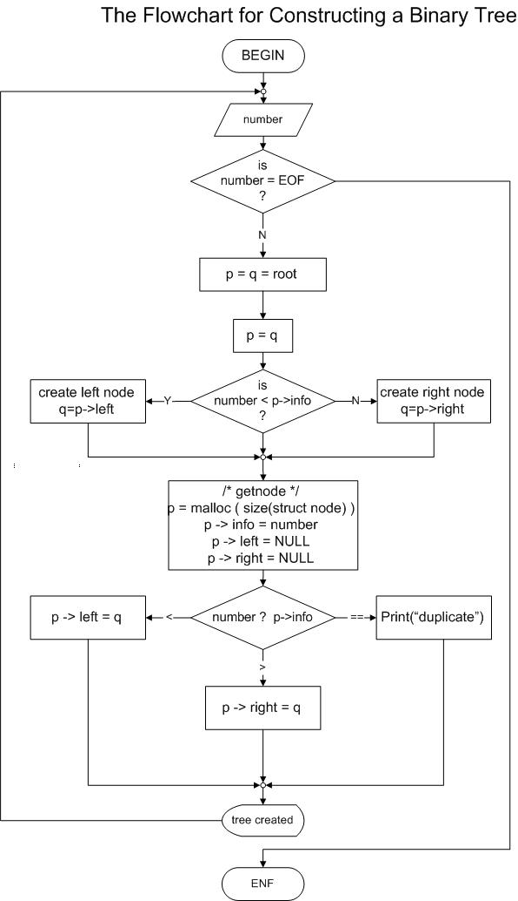

**5.2 Source Code:**

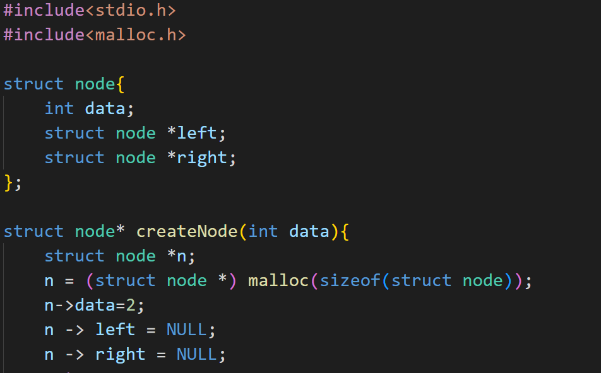

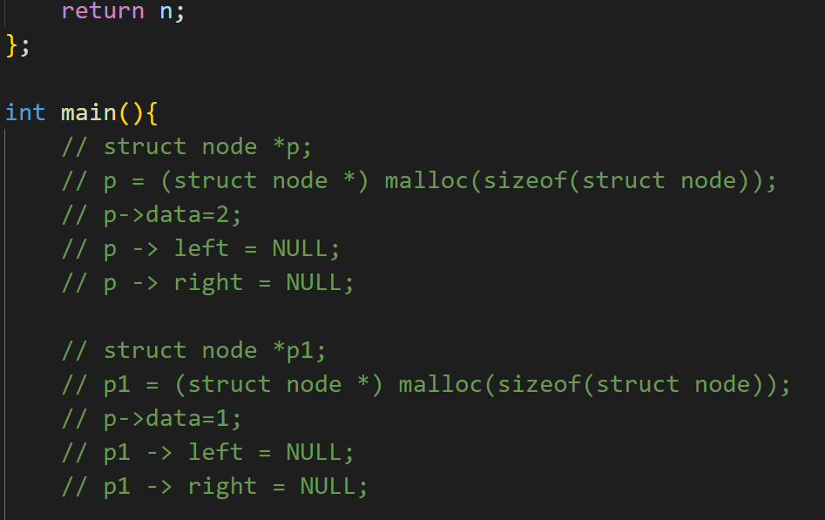

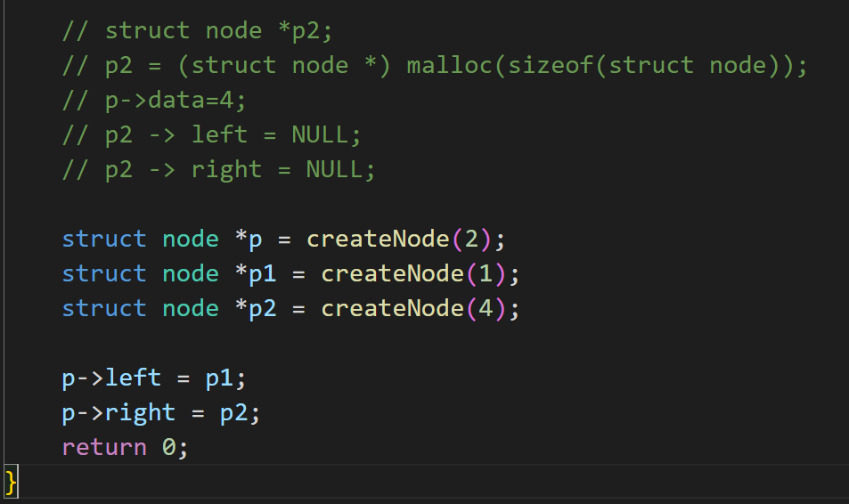

**6. Actual Resources Used:**

|  |  |  |  |  |
| --- | --- | --- | --- | --- |
| **Sr.**  **No.** | **Name of resource / material** | **Specification** | **Quantity** | **Remarks** |
| 1 | Computer | WINDOWS 11,8GB RAM, 160GB HDD | 1 |  |
| 2 | Operating System | WINDOWS 11 | 1 |  |
| 3 | Compiler | Turbo C/GCC/VS code | 1 |  |
| 4 | Browser | Chrome | 1 |  |

**7.Outputs of Micro-Projects:**

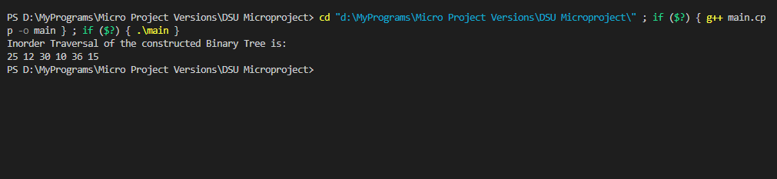

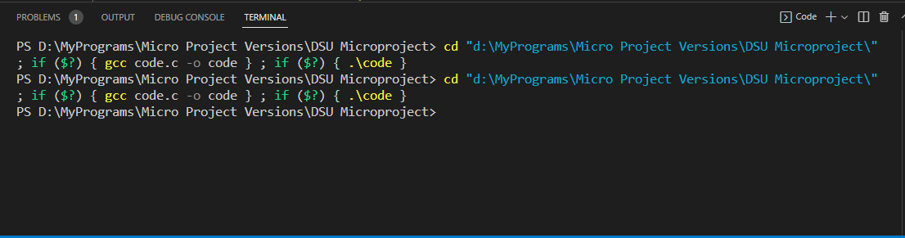

**8. Skill developed / Learning out of this Micro-Project:**

There are so many thing that we learn from this project of

1. We learn that how to make the project in C programming.

2. How to design computer terminal based programs in ‘C’ Language.

3. How to collect the information and how to make the presentation that we learn from this project.

4. We develop our logic implementation for programing and coding as well as for designing of terminal based program.

5. We learn much more functions of C header files.

6. We learn how C Program structure works.

7. We learn some keywords and functions from queue file.

8. We learn a lot more things like logic building and enhancement from this project.

**9. Applications of this Micro-Project:**

1. This is an open source program.
2. This is very helpful to store data into in computer using linked list.
3. This Terminal based program shows how a binary tree get converted into linked list.
4. Due to Data Structures we can able to do pull and push operation to linked list by binary tree.
5. Computer internally convert binary tree into linked list by the above program.

*********